e-Journal

on

MOBILE COMPUTING

SUBMITTED BY

**KALLIL RAHUL RAVIDNRAN**

ROLL NO:05

Submitted in partial fulfillment of the requirement for

Qualifying

M.Sc. Part I Semester II Examination

2018-19

Department of Information Technology

Ramniranjan Jhunjhunwala College

Station Road, Ghatkopar (w), Mumbai-86



**CERTIFICATE**

This is to certify that Mr. KALLIL RAHUL RAVINDRAN with Seat No. 05 has successfully completed the necessary course of experiments in the subject of **MOBILE COMPUTING**  during the academic year **2018 – 2019** complying with the requirements of **RAMNIRANJAN JHUNJHUNWALA COLLEGE OF ARTS, SCIENCE AND COMMERCE**, for the course of **M.Sc. (IT)** semester -II.

Internal Examiner Date:

Head of Department College Seal External Examiner

INDEX

|  |  |  |
| --- | --- | --- |
| **Sr. No** | **Practical** | **Page No.** |
| 1 | Simple Addition, multiplication, subtraction and division operations on windows mobile. | 4 |
| 2 | Calculate factorial, reverse, palindrome of a given number in windows mobile. | 10 |
| 3 | Design a currency converter in windows mobile. | 14 |
| 4 | A: Design a unit converter in windows mobile.  B: Design a temperature converter in windows mobile. | 18 |
| 5 | Design a standard calculator in windows mobile. | 28 |
| 6 | A: Design an EMI calculator in windows mobile.  B: Design a BMI calculator in windows mobile. | 35 |
| 7 | Design a Quiz program in windows mobile. | 42 |
| 8 | Design Link Navigation Application in Android/Windows Mobile. | 46 |
| 9 | Design Image Dropdown List in Windows Mobile. | 51 |
| 10 | Design Graphics (display circle, square, rectangle, etc.) Application in Windows Mobile | 54 |

**Practical No 1**

**Aim:** Simple Addition, multiplication, subtraction and division operations on windows mobile.

Start -> Visual Studio 2008 -> File ->New -> Project

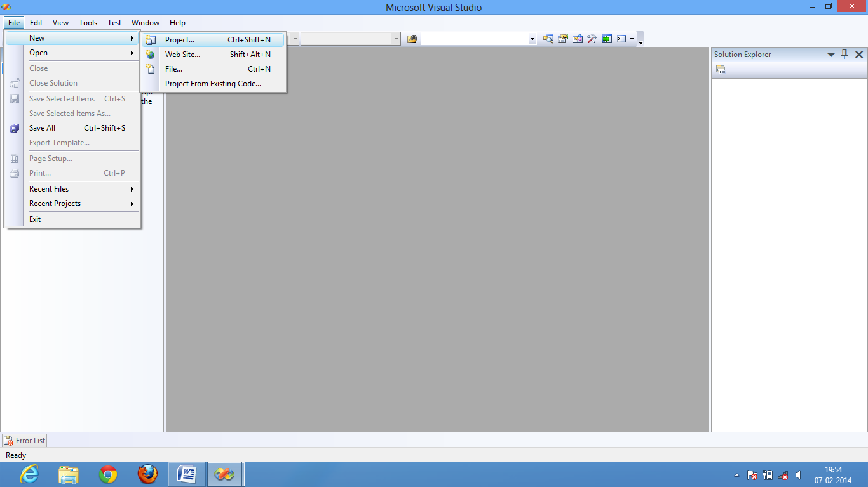

Wizard will get open -> expand other languages -> expand visual c# -> select smart device -> smart device project -> give the file name -> OK

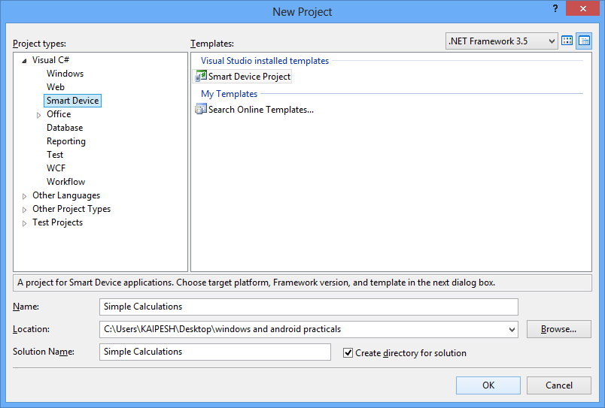

Wizard will open -> select target platform : windows mobile 5.0 pocket PC SDK -> select .NET Compact framework version 3.5 -> select Device application -> OK

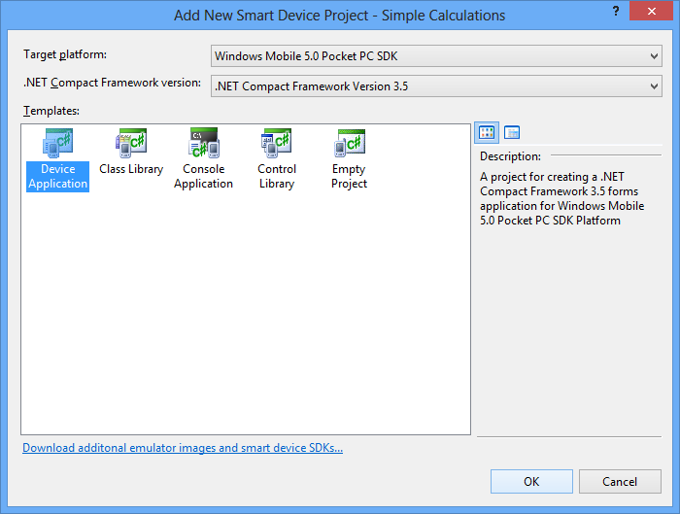

Create a GUI -> and implement the code

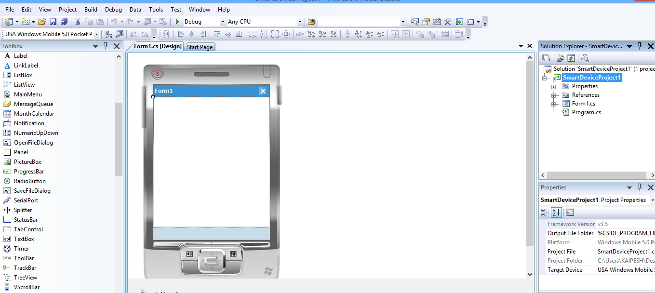

Add the following Labels, Textbox and Buttons as shown below

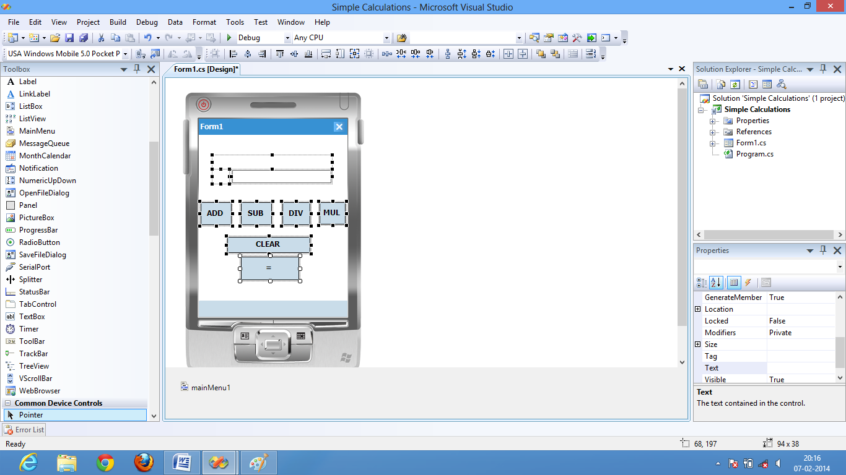

Change the name properties of each of this as shown below

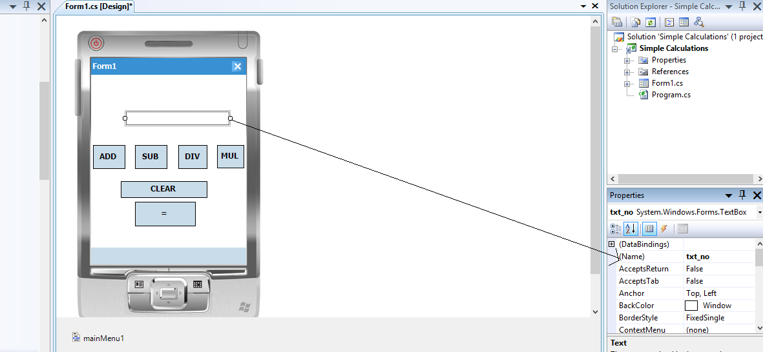

**Code:**

using System;

using System.Linq;

using System.Collections.Generic;

using System.ComponentModel;

using System.Data;

using System.Drawing;

using System.Text;

using System.Windows.Forms;

namespace practs1

{

public partial class Form1 : Form

{

String ans;

int c,i,j;

public Form1()

{

InitializeComponent();

}

Double click on ADD button

private void add_Click(object sender, EventArgs e)

{

lbl_sign.Text = "+";

lbl_temp.Text = txt_no.Text;

txt_no.Text = "";

}

Double click on SUB button

private void sub_Click(object sender, EventArgs e)

{

lbl_sign.Text = "-";

lbl_temp.Text = txt_no.Text;

txt_no.Text = "";

}

Double click on DIV button

private void div_Click(object sender, EventArgs e)

{

lbl_sign.Text = "/";

lbl_temp.Text = txt_no.Text;

txt_no.Text = "";

}

Double click on MUL button

private void mul_Click(object sender, EventArgs e)

{

lbl_sign.Text = "*";

lbl_temp.Text = txt_no.Text;

txt_no.Text = "";

}

Double click on CLEAR button

private void clear_Click(object sender, EventArgs e)

{

txt_no.Text = "";

lbl_temp.Text = "";

lbl_sign.Text = "";

}

Double click on = button

private void equal_Click(object sender, EventArgs e)

{

if (lbl_sign.Text == "+")

{

a = Convert.ToDouble(lbl_temp.Text);

b = Convert.ToDouble(txt_no.Text);

ans = a + b;

lbl_temp.Text = Convert.ToString(ans);

txt_no.Text = lbl_temp.Text;

lbl_temp.Text = null;

}

else if (lbl_sign.Text == "-")

{

a = Convert.ToDouble(lbl_temp.Text);

b = Convert.ToDouble(txt_no.Text);

ans = a - b;

lbl_temp.Text = Convert.ToString(ans);

txt_no.Text = lbl_temp.Text;

lbl_temp.Text = null;

}

else if (lbl_sign.Text == "/")

{

a = Convert.ToDouble(lbl_temp.Text);

b = Convert.ToDouble(txt_no.Text);

ans = a / b;

lbl_temp.Text = Convert.ToString(ans);

txt_no.Text = lbl_temp.Text;

lbl_temp.Text = null;

}

else if (lbl_sign.Text == "*"){

a = Convert.ToDouble(lbl_temp.Text);

b = Convert.ToDouble(txt_no.Text);

ans = a * b;

lbl_temp.Text = Convert.ToString(ans);

txt_no.Text = lbl_temp.Text;

lbl_temp.Text = null;

}

else { }

}

}

}

After code implemetation run the GUI interface -> select any one option from the wizard -> click on Deploy

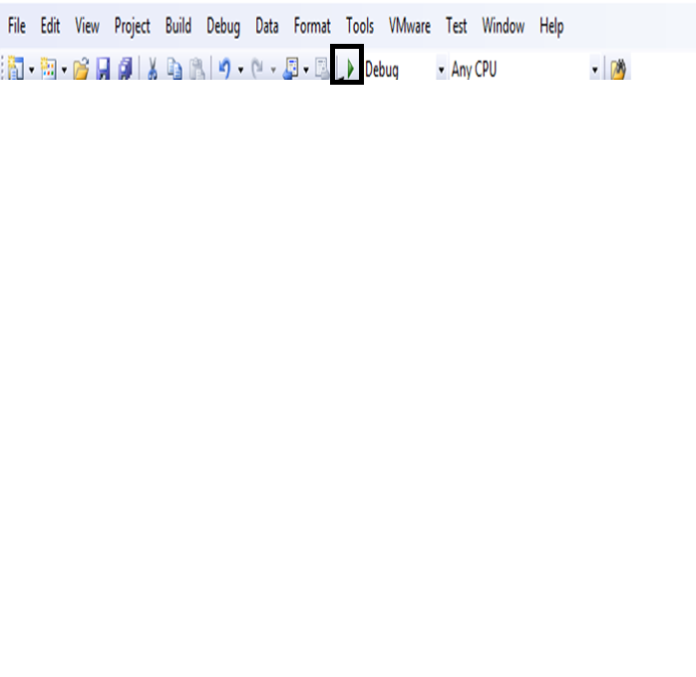

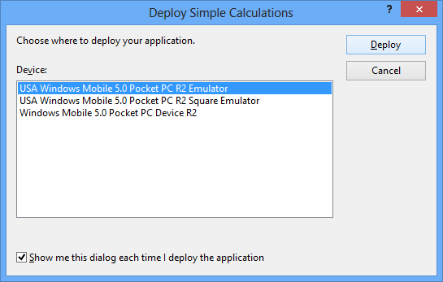

**Output :**

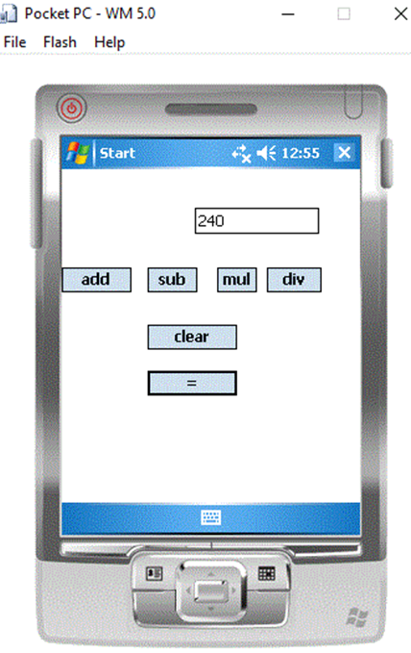

**Practical No 2**

**Aim:** Calculate factorial, reverse, palindrome of a given number in windows mobile.

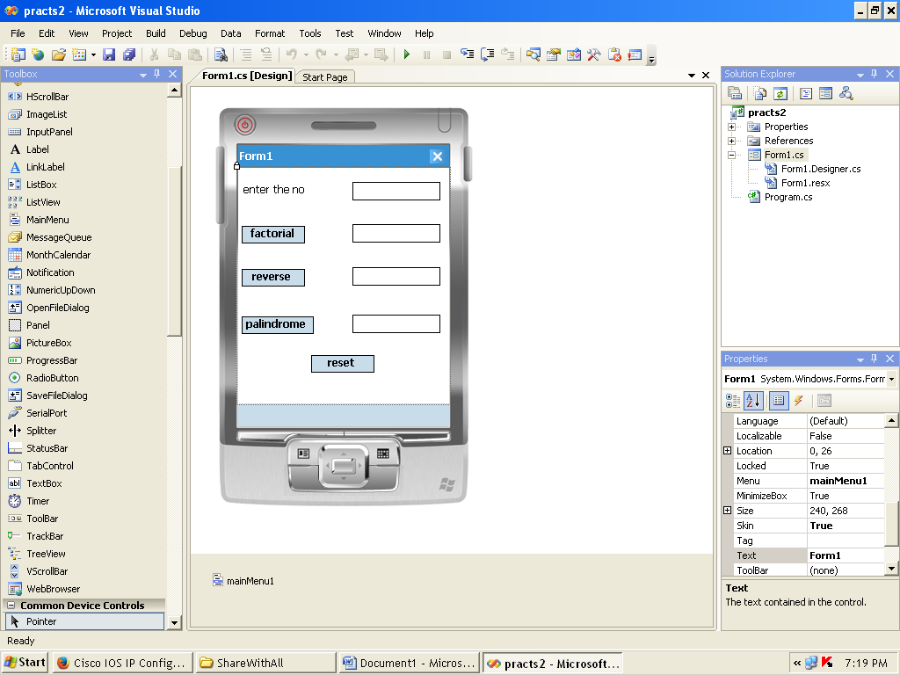

**Code:**

using System;

using System.Linq;

using System.Collections.Generic;

using System.ComponentModel;

using System.Data;

using System.Drawing;

using System.Text;

using System.Windows.Forms;

namespace practs2

{

public partial class Form1 : Form

{

int d;

int num;

public Form1()

{

InitializeComponent();

}

private void b1_Click(object sender, EventArgs e)

{

num = Convert.ToInt32(t1.Text);

Int64 fact = 1;

for(int i=1;i<=num;i++)

{

fact=fact*i;

}

t2.Text = fact.ToString();

}

private void b2_Click(object sender, EventArgs e)

{

num = Convert.ToInt32(t1.Text);

int rev=0;

while (num > 0)

{

d = num % 10;

rev = rev * 10 + d;

num = num / 10;

}

t3.Text = rev.ToString();

}

private void b3_Click(object sender, EventArgs e)

{

num = Convert.ToInt32(t1.Text);

int num1 = num;

int rev = 0;

while (num > 0)

{

d = num % 10;

rev = rev * 10 + d;

num = num / 10;

}

if (rev == num1)

{

t4.Text = "number is a pallindrome";

}

else

{

t4.Text = "No. is not a pallindrome";

}

}

private void b4_Click(object sender, EventArgs e)

{

t1.Text = "";

t2.Text = "";

t3.Text = "";

t4.Text = "";

}

}

}

**Output:**

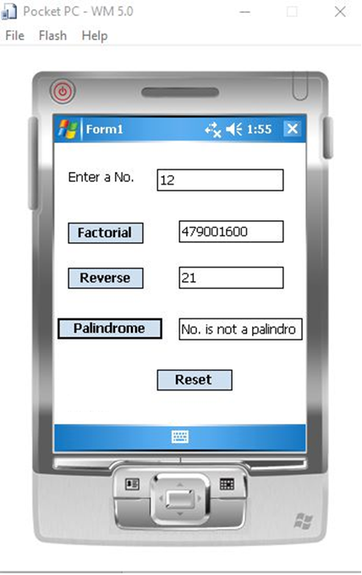

**Practical No 3**

**Aim:** Design a currency converter in windows mobile.

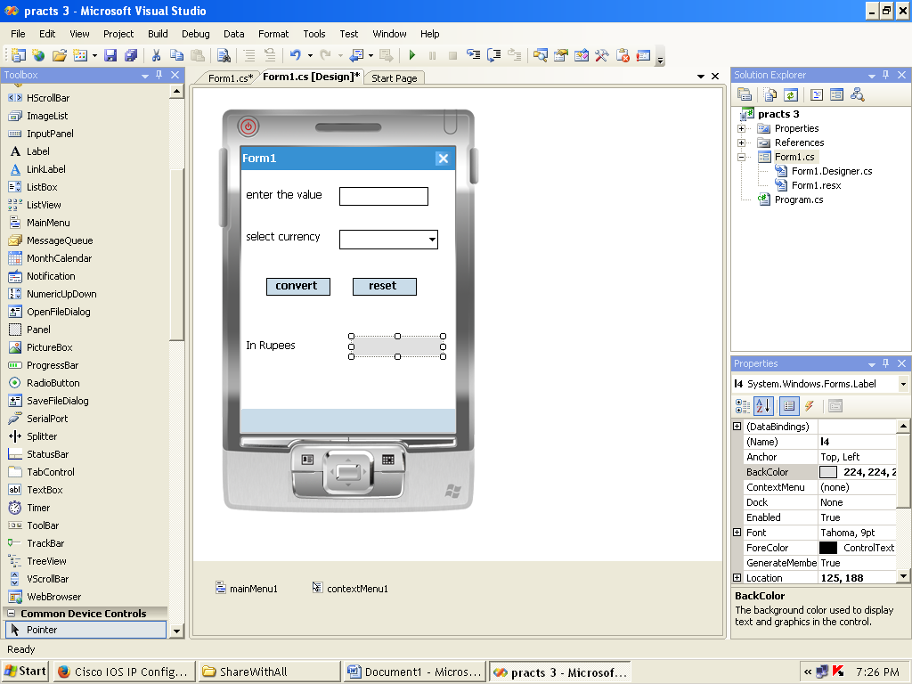

**Code:**

using System;

using System.Linq;

using System.Collections.Generic;

using System.ComponentModel;

using System.Data;

using System.Drawing;

using System.Text;

using System.Windows.Forms;

namespace practs_3

{

public partial class Form1 : Form

{

double value,ans;

string curr;

public Form1()

{

InitializeComponent();

}

private void textBox1_TextChanged(object sender, EventArgs e)

{

value = Convert.ToDouble(t1.Text);

}

private void c1_SelectedIndexChanged(object sender, EventArgs e)

{

curr = c1.Text;

}

private void b1_Click(object sender, EventArgs e)

{

if (t1.Text == "")

{

MessageBox.Show("enter the value");

}

if (curr == "dollar")

{

ans = value * 61.22;

l4.Text = ans.ToString();

}

if (curr == "yen")

{

ans = value * 0.60;

l4.Text = ans.ToString();

}

if (curr == "pounds")

{

ans = value * 101.76;

l4.Text = ans.ToString();

}

}

private void b2_Click(object sender, EventArgs e)

{

t1.Text = "";

c1.Text = "";

l4.Text = "";

}

}

}

**Output:**

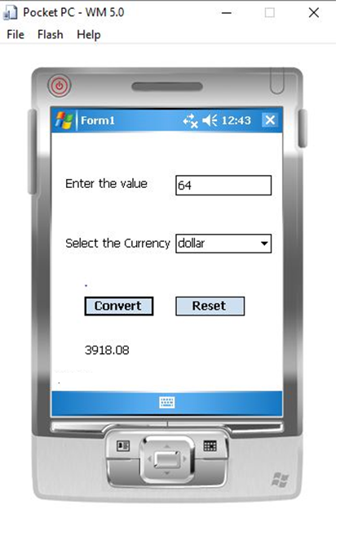

**Practical No: 4A**

**Aim:** Design a unit converter in windows mobile.

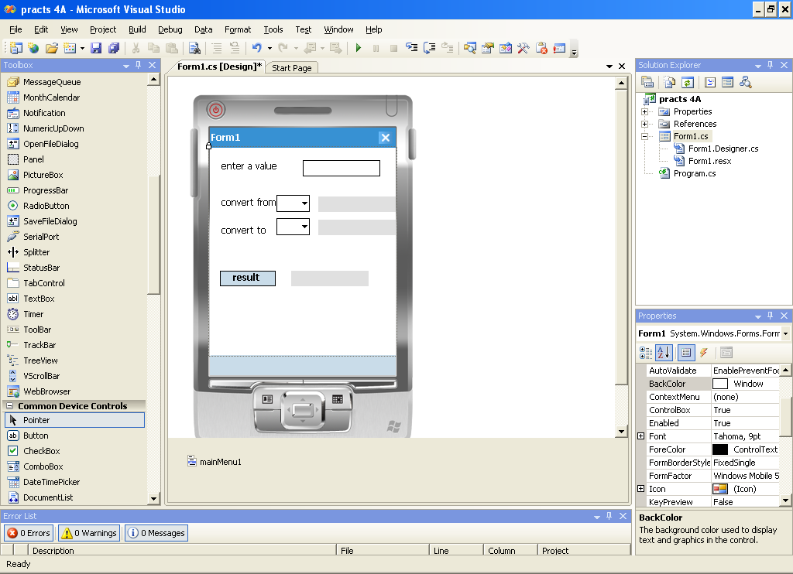

**Code:**

using System;

using System.Linq;

using System.Collections.Generic;

using System.ComponentModel;

using System.Data;

using System.Drawing;

using System.Text;

using System.Windows.Forms;

namespace practs_4A

{

public partial class Form1 : Form

{

double a,b;

string v;

public Form1()

{

InitializeComponent();

}

private void t1_TextChanged(object sender, EventArgs e)

{

a = Convert.ToDouble(t1.Text);

}

private void c1_SelectedIndexChanged(object sender, EventArgs e)

{

if (c1.Text == "cm")

{

l4.Text = "centimeter";

}

if (c1.Text == "m")

{

l4.Text = "meter";

}

if (c1.Text == "mm")

{

l4.Text = "millimeter";

}

if (c1.Text == "km")

{

l4.Text = "kilometer";

}

if (c1.Text == "inch")

{

l4.Text = "inches";

}

if (c1.Text == "foot")

{

l4.Text = "feet";

}

}

private void c2_SelectedIndexChanged(object sender, EventArgs e)

{

if (c2.Text == "cm")

{

l5.Text = "centimeter";

}

if (c2.Text == "m")

{

l5.Text = "meter";

}

if (c2.Text == "mm")

{

l5.Text = "millimeter";

}

if (c2.Text == "km")

{

l5.Text = "kilometer";

}

if (c2.Text == "inch")

{

l5.Text = "inches";

}

if (c2.Text == "foot")

{

l5.Text = "feet";

}

}

private void b1_Click(object sender, EventArgs e)

{

if (c1.Text == "mm"&& c2.Text == "mm")

{

l7.Text = a.ToString();

}

if (c1.Text == "mm"&& c2.Text == "cm")

{

b = a*0.1;

l7.Text = b.ToString();

}

if (c1.Text == "mm"&& c2.Text == "m")

{

b = a * 0.001;

l7.Text = b.ToString();

}

if (c1.Text == "mm"&& c2.Text == "km")

{

b = a * 0.000001;

l7.Text = b.ToString();

}

if (c1.Text == "mm"&& c2.Text == "inch")

{

b = a * 0.0393;

l7.Text = b.ToString();

}

if (c1.Text == "mm"&& c2.Text == "foot")

{

b = a * 0.0032;

l7.Text = b.ToString();

}

if (c1.Text == "cm"&& c2.Text == "mm")

{

b = a * 10;

l7.Text = b.ToString();

}

if (c1.Text == "cm"&& c2.Text == "cm")

{

l7.Text = a.ToString();

}

if (c1.Text == "cm"&& c2.Text == "m")

{

b = a /100;

l7.Text = b.ToString();

}

if (c1.Text == "cm"&& c2.Text == "km")

{

b = a / 100000;

l7.Text = b.ToString();

}

if (c1.Text == "cm"&& c2.Text == "inch")

{

b = a *0.3937;

l7.Text = b.ToString();

}

if (c1.Text == "cm"&& c2.Text == "foot")

{

b = a *0.0328;

l7.Text = b.ToString();

}

if (c1.Text == "m"&& c2.Text == "mm")

{

b = a * 1000;

l7.Text = b.ToString();

}

if (c1.Text == "m"&& c2.Text == "cm")

{

b = a * 100;

l7.Text = b.ToString();

}

if (c1.Text == "m"&& c2.Text == "m")

{

l7.Text = a.ToString();

}

if (c1.Text == "m"&& c2.Text == "km")

{

b = a /1000;

l7.Text = b.ToString();

}

if (c1.Text == "m"&& c2.Text == "inch")

{

b = a * 39.37;

l7.Text = b.ToString();

}

if (c1.Text == "m"&& c2.Text == "foot")

{

b = a / 3;

l7.Text = b.ToString();

}

if (c1.Text == "km"&& c2.Text == "mm")

{

b = a * 1000000;

l7.Text = b.ToString();

}

if (c1.Text == "km"&& c2.Text == "cm")

{

b = a *100000;

l7.Text = b.ToString();

}

if (c1.Text == "km"&& c2.Text == "m")

{

b = a * 1000;

l7.Text = b.ToString();

}

if (c1.Text == "km"&& c2.Text == "km")

{

l7.Text = a.ToString();

}

if (c1.Text == "km"&& c2.Text == "inch")

{

b = a * 39370.0787;

l7.Text = b.ToString();

}

if (c1.Text == "km"&& c2.Text == "foot")

{

b = a *3280.8399;

l7.Text = b.ToString();

}

if (c1.Text == "inch"&& c2.Text == "mm")

{

b = a * 25.4;

l7.Text = b.ToString();

}

if (c1.Text == "inch"&& c2.Text == "cm")

{

b = a * 2.54;

l7.Text = b.ToString();

}

if (c1.Text == "inch"&& c2.Text == "m")

{

b = a *0.0254;

l7.Text = b.ToString();

}

if (c1.Text == "inch"&& c2.Text == "km")

{

b = a *0.0000254;

l7.Text = b.ToString();

}

if (c1.Text == "inch"&& c2.Text == "inch")

{

l7.Text = a.ToString();

}

if (c1.Text == "inch"&& c2.Text == "foot")

{

b = a * 0.0833;

l7.Text = b.ToString();

}

if (c1.Text == "foot"&& c2.Text == "mm")

{

b = a * 304.8;

l7.Text = b.ToString();

}

if (c1.Text == "foot"&& c2.Text == "cm")

{

b = a * 30.48;

l7.Text = b.ToString();

}

if (c1.Text == "foot"&& c2.Text == "m")

{

b = a * 0.3048;

l7.Text = b.ToString();

}

if (c1.Text == "foot"&& c2.Text == "km")

{

b = a * 0.0003048;

l7.Text = b.ToString();

}

if (c1.Text == "foot"&& c2.Text == "inch")

{

b = a *12;

l7.Text = b.ToString();

}

if (c1.Text == "foot"&& c2.Text == "foot")

{

l7.Text = a.ToString();

}

}

}

}

**Output:**

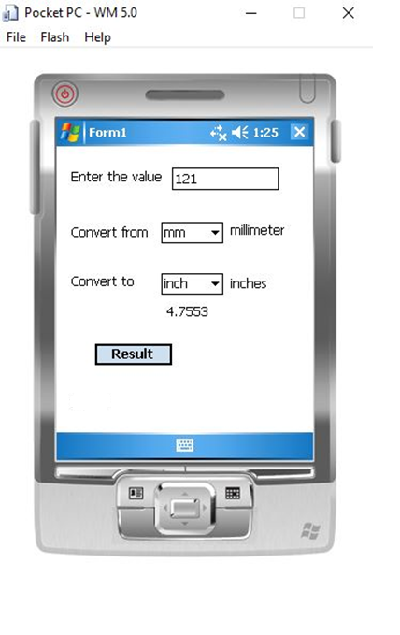

**Practical No: 4B**

**Aim:** Design a temperature converter in windows mobile.

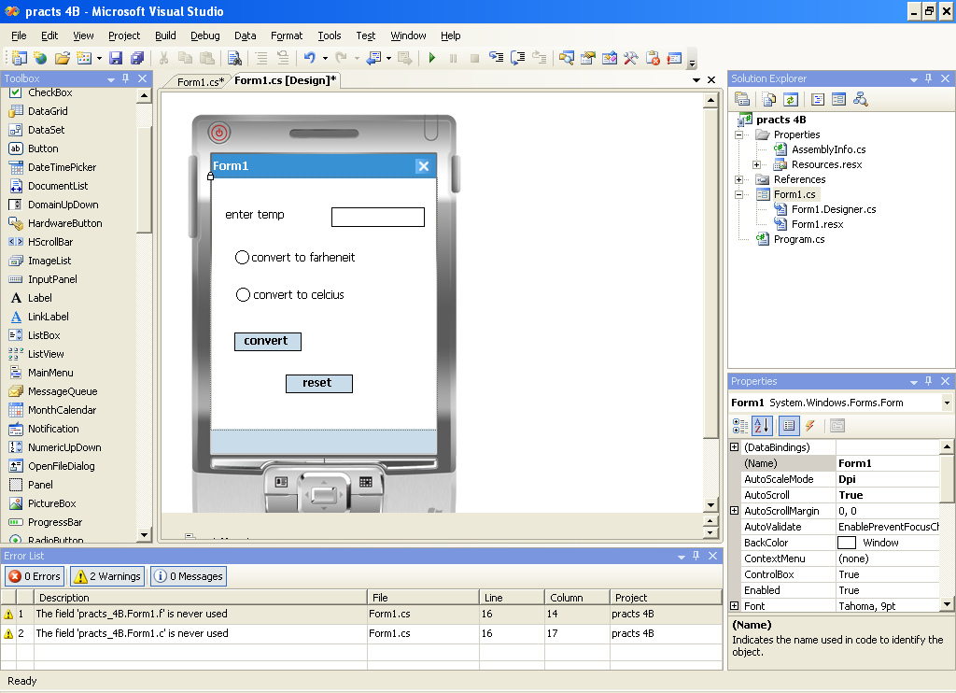

**Code:**

using System;

using System.Linq;

using System.Collections.Generic;

using System.ComponentModel;

using System.Data;

using System.Drawing;

using System.Text;

using System.Windows.Forms;

namespace practs_4B

{

public partial class Form1 : Form

{

bool f, c;

public Form1()

{

InitializeComponent();

}

private void button1_Click(object sender, EventArgs e)

{

if(r1.Checked == true)

{

double temp = Convert.ToDouble(t1.Text);

double ans = (temp * (9 / 5)) + 32;

t2.Text=ans.ToString();

}

if (r2.Checked == true)

{

double temp = Convert.ToDouble(t1.Text);

double ans = ((temp - 32) *5 / 9);

t2.Text = ans.ToString();

}

}

private void button2_Click(object sender, EventArgs e)

{

t1.Text = "";

t2.Text = "";

}

}

}

**Output :**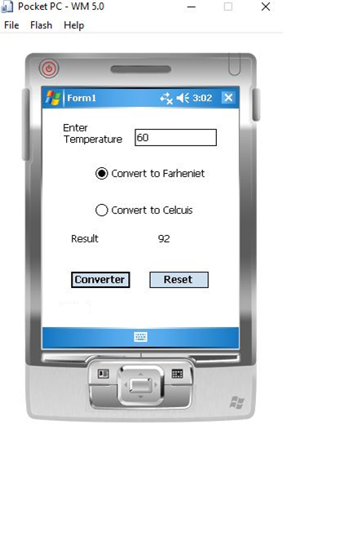

**Practical No: 5**

**Aim:** Design a standard calculator in windows mobile.

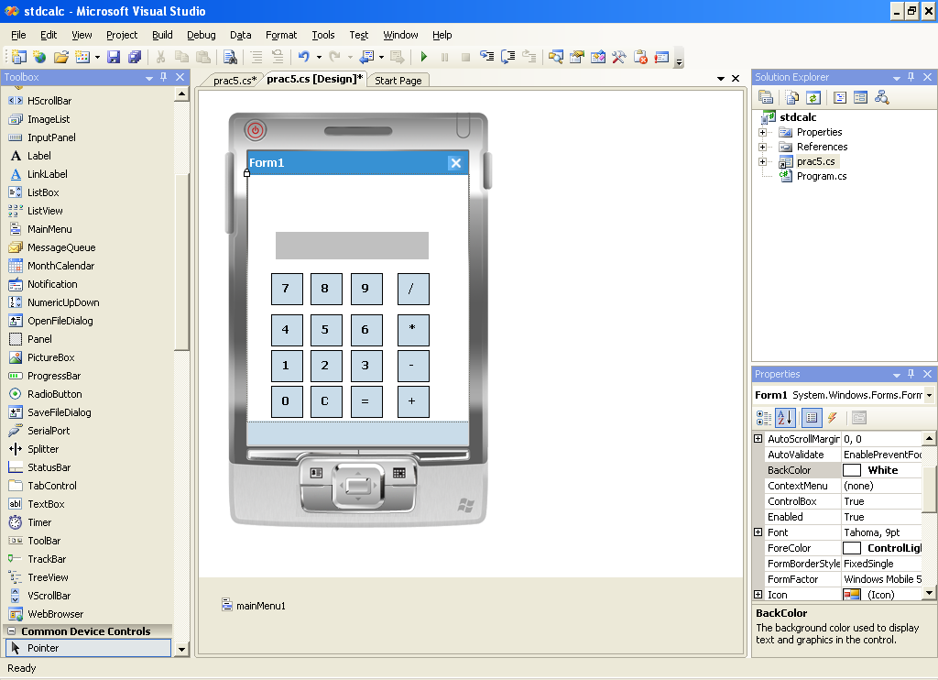

**Code:**

using System;

using System.Linq;

using System.Collections.Generic;

using System.ComponentModel;

using System.Data;

using System.Drawing;

using System.Text;

using System.Windows.Forms;

namespace stdcalc

{

public partial class Form1 : Form

{

public Form1()

{

InitializeComponent();

}

privatedouble num1;

privatedouble num2;

privatestring cal;

privatebool inputstatus = true;

private void btn0_Click(object sender, EventArgs e)

{

if (inputstatus)

{

if (lblans.Text.Length >= 1)

{

lblans.Text += btn0.Text;

}

}

}

private void btn1_Click(object sender, EventArgs e)

{

if (inputstatus)

{

lblans.Text += btn1.Text;

}

else

{

lblans.Text = btn1.Text;

inputstatus = true;

}

}

private void btn2_Click(object sender, EventArgs e)

{

if (inputstatus)

{

lblans.Text += btn2.Text;

}

else

{

lblans.Text = btn2.Text;

inputstatus = true;

}

}

private void btn3_Click(object sender, EventArgs e)

{

if (inputstatus)

{

lblans.Text += btn3.Text;

}

else

{

lblans.Text = btn3.Text;

inputstatus = true;

}

}

private void btn4_Click(object sender, EventArgs e)

{

if (inputstatus)

{

lblans.Text += btn4.Text;

}

else

{

lblans.Text = btn4.Text;

inputstatus = true;

}

}

private void btn5_Click(object sender, EventArgs e)

{

if (inputstatus)

{

lblans.Text += btn5.Text;

}

else

{

lblans.Text = btn5.Text;

inputstatus = true;

}

}

private void btn6_Click(object sender, EventArgs e)

{

if (inputstatus)

{

lblans.Text += btn6.Text;

}

else

{

lblans.Text = btn6.Text;

inputstatus = true;

}

}

private void btn7_Click(object sender, EventArgs e)

{

if (inputstatus)

{

lblans.Text += btn7.Text;

}

else

{

lblans.Text = btn7.Text;

inputstatus = true;

}

}

private void btn8_Click(object sender, EventArgs e)

{

if (inputstatus)

{

lblans.Text += btn8.Text;

}

else

{

lblans.Text = btn8.Text;

inputstatus = true;

}

}

private void btn9_Click(object sender, EventArgs e)

{

if (inputstatus)

{

lblans.Text += btn9.Text;

}

else

{

lblans.Text = btn9.Text;

inputstatus = true;

}

}

private void btnadd_Click(object sender, EventArgs e)

{

if (lblans.Text.Length != 0)

{

num1 = System.Double.Parse(lblans.Text);

result();

cal = "+";

}

}

private void btnsub_Click(object sender, EventArgs e)

{

if (lblans.Text.Length != 0)

{

num1 = System.Double.Parse(lblans.Text);

result();

cal = "-";

}

}

private void btnmul_Click(object sender, EventArgs e)

{

if (lblans.Text.Length != 0)

{

num1 = System.Double.Parse(lblans.Text);

result();

cal = "*";

}

}

private void btndiv_Click(object sender, EventArgs e)

{

if (lblans.Text.Length != 0)

{

num1 = System.Double.Parse(lblans.Text);

result();

cal = "/";

}

}

private void btnequl_Click(object sender, EventArgs e)

{

result();

cal = string.Empty;

}

private void btn_Click(object sender, EventArgs e)

{

lblans.Text = string.Empty;

num1 = 0;

num2 = 0;

cal = string.Empty;

}

private void result()

{

num2 = System.Double.Parse(lblans.Text);

switch (cal)

{

case"+":

num1 = num1 + num2;

break;

case"-":

num1 = num1 - num2;

break;

case"*":

num1 = num1 * num2;

break;

case"/":

num1 = num1 / num2;

break;

}

lblans.Text = num1.ToString();

inputstatus = false;

}

}

}

**Output :**

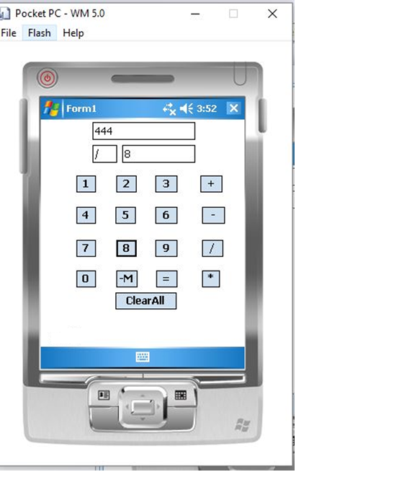

**Practical No: 6**

**Aim:** Design Graphics (display circle, square, rectangle, etc.) Application in Windows Mobile

Insert one tab control and add tabs from tab Pages Property from property window

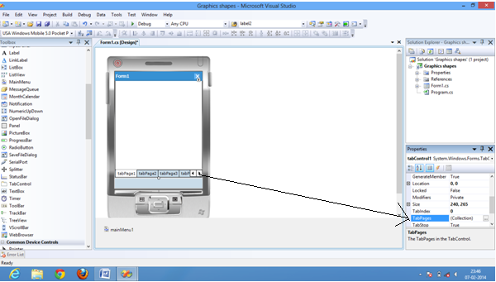

Change the text property of tab pages and add button in that tabpage also change the name and text property of button to the desired names

For eg in tab 1 the text of the tabpage is changed to “TEXT” and name of the button is changed to “btn_text”

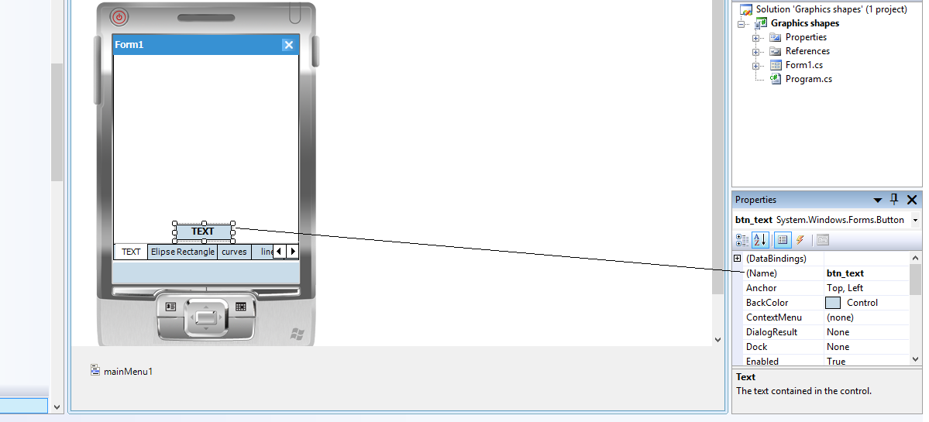

Right click on form1 and click view code

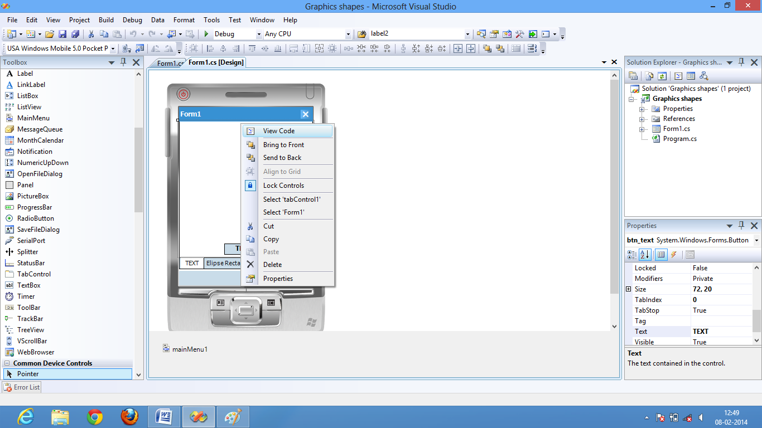

**Code:**

using System;

using System.Linq;

using System.Collections.Generic;

using System.ComponentModel;

using System.Data;

using System.Drawing;

using System.Text;

using System.Windows.Forms;

namespace ImageChange{

public partial class Form1 : Form

{

public Form1()

{

InitializeComponent();

}

private void DrawString()

{

System.Drawing.Graphics tabgraphics = tabPage1.CreateGraphics();

string drawString = "Sample Text";

System.Drawing.Font drawFont = new System.Drawing.Font("Arial", 16, FontStyle.Bold);

System.Drawing.SolidBrush drawBrush = new System.Drawing.SolidBrush(System.Drawing.Color.Black);

float x = 60.0f;

float y = 50.0f;

tabgraphics.DrawString(drawString, drawFont, drawBrush, x, y);

drawFont.Dispose();

drawBrush.Dispose();

tabgraphics.Dispose();

}

**Double click on TEXT button of tabpage 1**

private void btn_text_Click(object sender, EventArgs e)

{

DrawString();

}

**For tabpage 2**

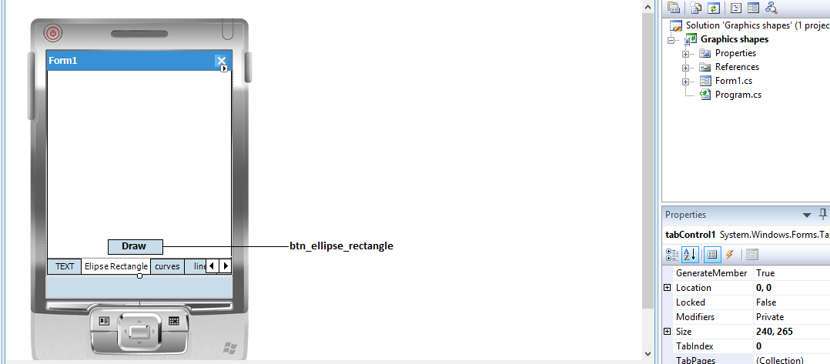

**Add the following function**

private void DrawIt()

{

Pen p = new Pen(Color.Black);

System.Drawing.Graphics tabgraphics1 = tabPage2.CreateGraphics();

System.Drawing.Rectangle rectangle = new System.Drawing.Rectangle(50, 50, 150, 150);

tabgraphics1.DrawEllipse(p, rectangle);

tabgraphics1.DrawRectangle(p, rectangle);

}

**Double click on Draw button**

private void btn_ellipse_rectangle_Click(object sender, EventArgs e)

{

DrawIt();

}

**For tab page 3**

**Change the name property**

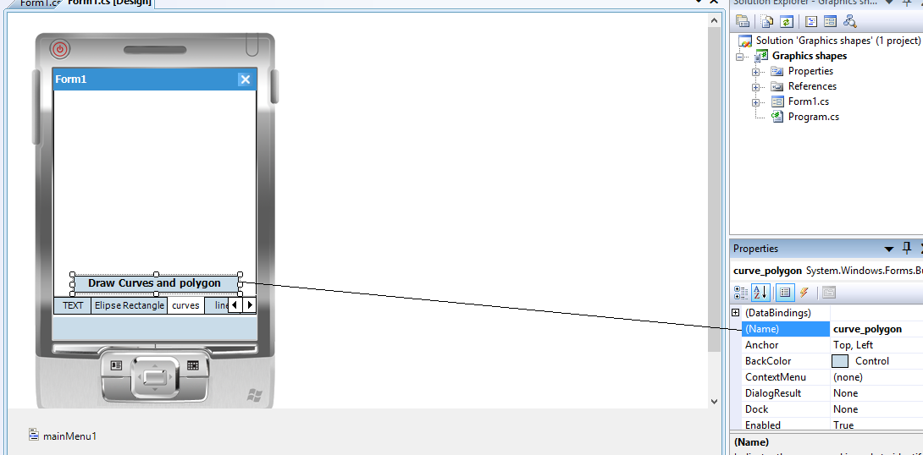

**Add the following function in code**

private void curves()

{

System.Drawing.Graphics tabgraphics2 = tabPage3.CreateGraphics();

System.Drawing.Pen myPen;

myPen = new System.Drawing.Pen(System.Drawing.Color.Black);

tabgraphics2.DrawEllipse(myPen, 0, 0, 200, 200);

tabgraphics2.DrawEllipse(myPen, 120, 40, 40, 40);

tabgraphics2.DrawEllipse(myPen, 40, 40, 40, 40);

Point[] apt = new Point[4];

apt[0] = new Point(60, 140);

apt[1] = new Point(140, 150);

apt[2] = new Point(100, 180);

apt[3] = new Point(60, 140);

tabgraphics2.DrawPolygon(myPen, apt);

}

**Double click on Draw curve and polygon button**

private void curve_polygon_Click(object sender, EventArgs e)

{

curves();

}

**For tab page 4**

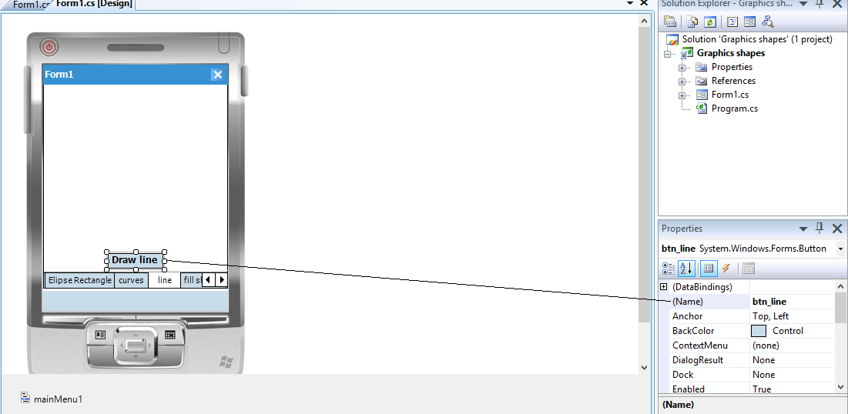

**Add the following function in code for lines**

private void lines()

{

Pen p = new Pen(Color.BlueViolet);

System.Drawing.Graphics tabgraphics3 = tabpage4.CreateGraphics();

for (int i = 100; i > 10;i-=5 )

{

tabgraphics3.DrawLine(p, 50,100, i,i);

}

Point[] apt1 = new Point[4];

apt1[0] = new Point(60, 140);

apt1[1] = new Point(140, 150);

apt1[2] = new Point(100, 180);

apt1[3] = new Point(60, 140);

tabgraphics3.DrawLines(p, apt1);

}

**Double click on Draw Line button**

private void btn_line_Click(object sender, EventArgs e)

{

lines();

}

**For tab page 5**

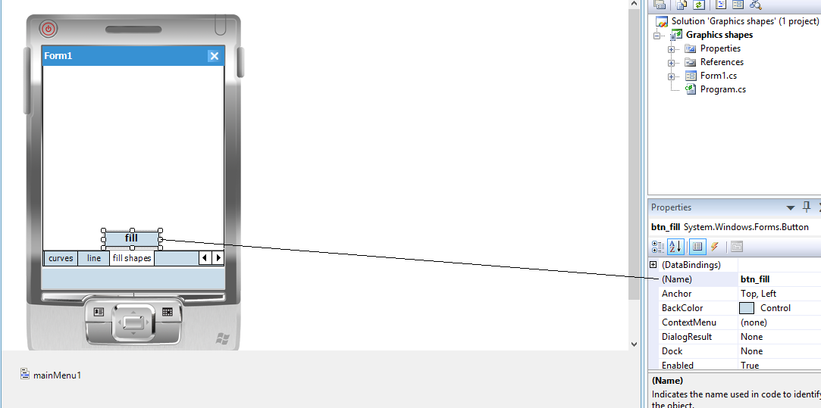

**Add the following function in code**

private void fill_shapes()

{

System.Drawing.SolidBrush brush1 = new System.Drawing.SolidBrush(System.Drawing.Color.Red);

System.Drawing.Graphics tabGraphics = tabPage5.CreateGraphics();

tabGraphics.FillEllipse(brush1, new System.Drawing.Rectangle(50, 50, 75, 30));

brush1.Dispose();

System.Drawing.SolidBrush brush2 = new System.Drawing.SolidBrush(System.Drawing.Color.Blue);

System.Drawing.Graphics tabGraphics1 = tabPage5.CreateGraphics();

tabGraphics1.FillRectangle(brush2, new System.Drawing.Rectangle(150, 150, 100, 150));

brush2.Dispose();

tabGraphics1.Dispose();

Point[] apt1 = new Point[4];

apt1[0] = new Point(60, 140);

apt1[1] = new Point(140, 150);

apt1[2] = new Point(100, 180);

apt1[3] = new Point(60, 140);

System.Drawing.SolidBrush brush3 = new System.Drawing.SolidBrush(System.Drawing.Color.Gold);

System.Drawing.Graphics tabGraphics2 = tabPage5.CreateGraphics();

tabGraphics2.FillPolygon(brush3,apt1);

brush1.Dispose();

tabGraphics.Dispose();

}

**Double click on fill button**

private void btn_fill_Click(object sender, EventArgs e)

{

fill_shapes();

}

**Output:**

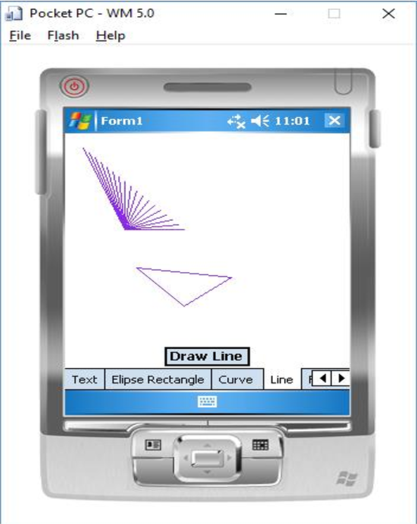

**Practical No: 7**

**Aim:** Design Link Navigator Application in Android/Windows Mobile.

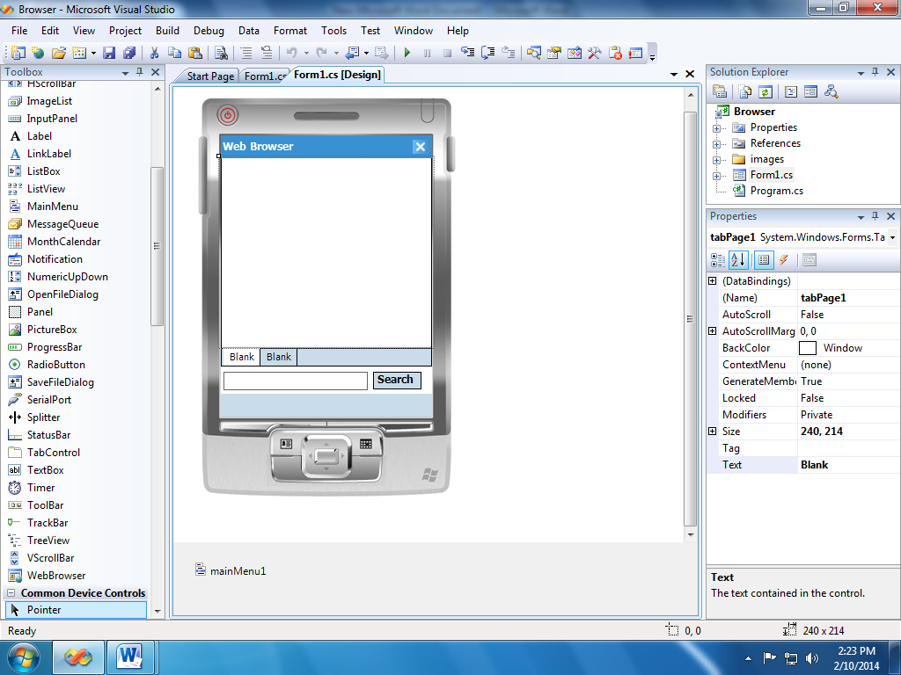

**Code:**

using System;

using System.Linq;

using System.Collections.Generic;

using System.ComponentModel;

using System.Data;

using System.Drawing;

using System.Text;

using System.Windows.Forms;

namespace practs_8

{

public partial class Form1 : Form

{

public Form1()

{

InitializeComponent();

}

private void enter_key_press(object sender, KeyEventArgs e)

{

if (e.KeyCode == Keys.Enter)

{

WebBrowser wb = new WebBrowser();

if (tabControl1.SelectedIndex == 0)

{

tabPage1.Controls.Add(wb);

wb.Dock = DockStyle.Fill;

System.Uri adr = new Uri("http://" + txt_adr.Text + "/");

wb.Navigate(adr);

try{

tabPage1.Text = wb.Url.Host.ToString();

}catch (Exception er){

tabPage1.Text = "Error";

System.Uri adr1 = new Uri(@"file://\Windows\default.htm");

wb.Navigate(adr1);

}

}else if (tabControl1.SelectedIndex == 1)

{

tabPage2.Controls.Add(wb);

wb.Dock = DockStyle.Fill;

System.Uri adr = new Uri("http://" + txt_adr.Text + "/");

wb.Navigate(adr);

try{

tabPage2.Text = wb.Url.Host.ToString();

}catch (Exception er)

{

tabPage2.Text = "Error";

System.Uri adr1 = new Uri(@"file://\Windows\default.htm");

wb.Navigate(adr1);

}

}else

{}

}

}

private void search_Click(object sender, EventArgs e)

{

WebBrowser wb = new WebBrowser();

if (tabControl1.SelectedIndex == 0)

{

tabPage1.Controls.Add(wb);

wb.Dock = DockStyle.Fill;

System.Uri adr = new Uri("http://" + txt_adr.Text + "/");

wb.Navigate(adr);

try{

tabPage1.Text = wb.Url.Host.ToString();

}catch (Exception er)

{

tabPage1.Text = "Error";

System.Uri adr1 = new Uri(@"file://\Windows\default.htm");

wb.Navigate(adr1);

}

}

else if (tabControl1.SelectedIndex == 1)

{

tabPage2.Controls.Add(wb);

wb.Dock = DockStyle.Fill;

System.Uri adr = new Uri("http://" + txt_adr.Text+"/");

wb.Navigate(adr);

try{

tabPage2.Text = wb.Url.Host.ToString();

}

catch (Exception er)

{

tabPage2.Text = "Error";

System.Uri adr1 = new Uri(@"file://\Windows\default.htm");

wb.Navigate(adr1);

}

}

else

{}

}

}

}

**Output:**

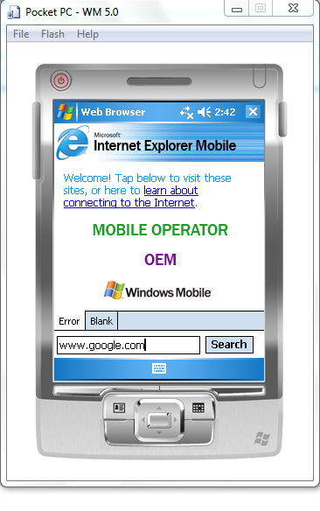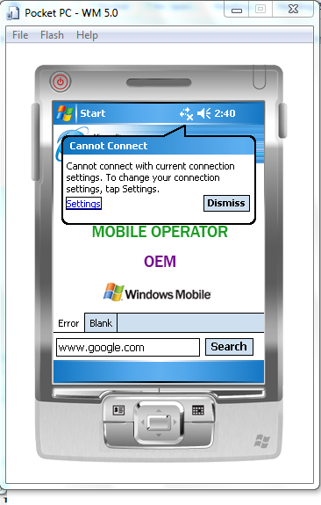

**Practical No: 8**

**Aim:** Design Link Navigator Application in Windows Mobile.

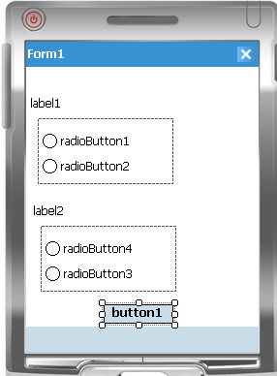

**Code:**

using System;

using System.Linq;

using System.Collections.Generic;

using System.ComponentModel;

using System.Data;

using System.Drawing;

using System.Text;

using System.Windows.Forms;

namespace practs_7

{

public partial class Form1 : Form

{

int score = 0;

public Form1(){

InitializeComponent();

}

private void button1_Click(object sender, EventArgs e)

{

if (radioButton1.Checked == true && radioButton3.Checked == true && radioButton5.Checked == true)

{

MessageBox.Show("Your Score is: 3");

}

if (radioButton1.Checked == true && radioButton3.Checked == true && radioButton5.Checked == false)

{

MessageBox.Show("Your Score is: 2");

}

if (radioButton1.Checked == true && radioButton3.Checked == false && radioButton5.Checked == false)

{

MessageBox.Show("Your Score is: 1");

}

if (radioButton1.Checked == false && radioButton3.Checked == false && radioButton5.Checked == false)

{

MessageBox.Show("Your Score is: 0");

}

if (radioButton1.Checked == true && radioButton3.Checked == false && radioButton5.Checked == true)

{

MessageBox.Show("Your Score is: 2");

}

if (radioButton1.Checked == false && radioButton3.Checked == true && radioButton5.Checked == true)

{

MessageBox.Show("Your Score is: 2");

}

if (radioButton1.Checked == false && radioButton3.Checked == false && radioButton5.Checked == true)

{

MessageBox.Show("Your Score is: 1");

}

}

}

}

**Output:**

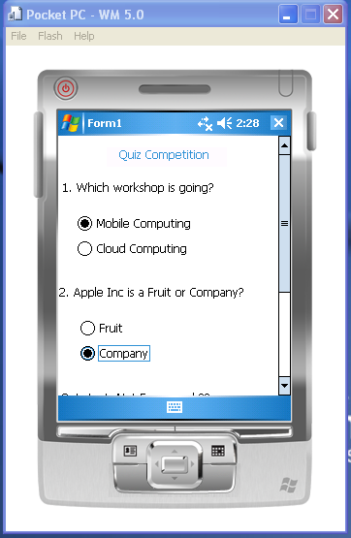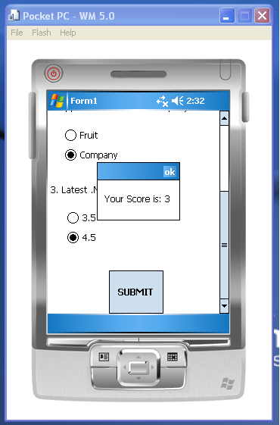

**Practical No: 9A**

**Aim:** Design a BMI caculator in windows mobile.

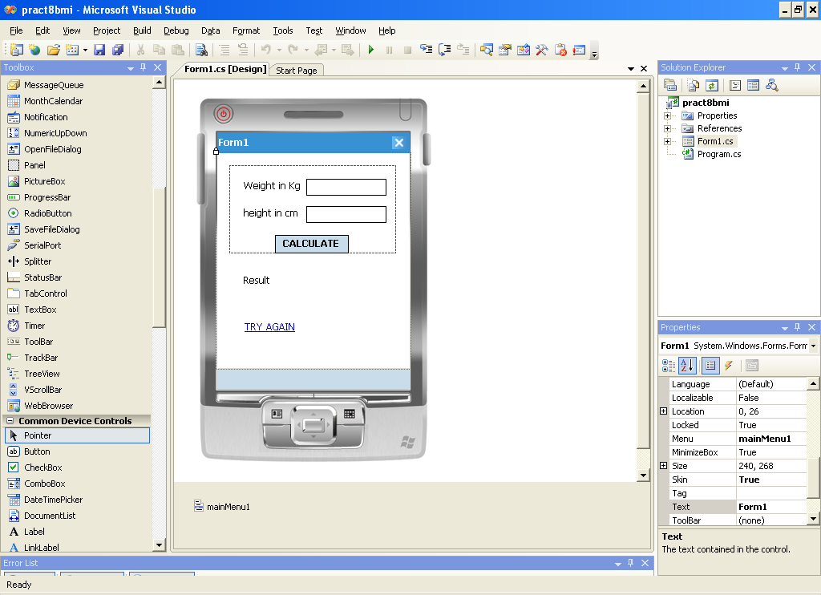

**Code :**

using System;

using System.Linq;

using System.Collections.Generic;

using System.ComponentModel;

using System.Data;

using System.Drawing;

using System.Text;

using System.Windows.Forms;

namespace bmi

{

public partial class Form1 : Form

{

public myForm1()

{

InitializeComponent();

}

private void Cal_Click(object sender, EventArgs e)

{

double w = double.Parse(txtwt.Text);

double h = double.Parse(txtht.Text);

h = h / 100;

double ht = h * h;

double ans = w / ht;

lblResult.Text=ans.ToString();

if (ans > 0 && ans <= 18)

{

lblbmi.Text="slim";

}

if (ans > 19 && ans <= 25)

{

lblbmi.Text="fit";

}

if (ans > 25)

{

lblbmi.Text="fat";

}

p1.Visible = false;

lblbmi.Visible = true;

label1.Visible = true;

lblResult.Visible = true;

linktry.Visible = true;

}

private void link_Click(object sender, EventArgs e)

{

Linktry.Visible=false;

txtht.Text = "";

txtwt.Text = "";

p1.Visible = true;

lblbmi.Visible = false;

label1.Visible = false;

lblResult.Visible = false;

}

private void myForm1_Load(object sender, EventArgs e)

{

lblbmi.Visible = false;

label1.Visible = false;

lblResult.Visible = false;

link.Visible = false;

}

}

}

**Output:**

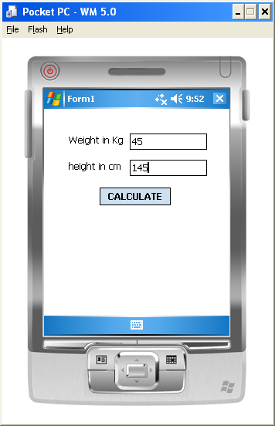

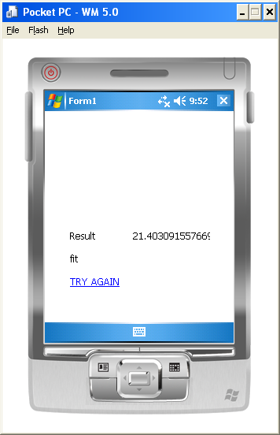

**Practical No: 9B**

**Aim:** Design an EMI calculator in windows mobile.

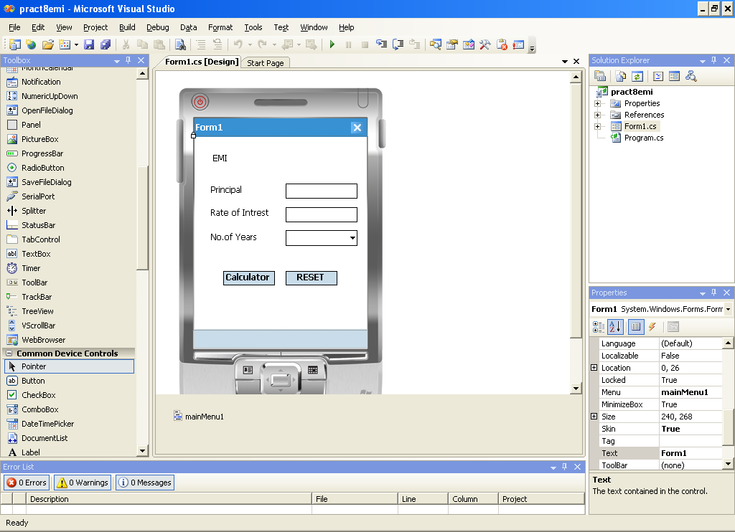

**Code:**

using System;

using System.Linq;

using System.Collections.Generic;

using System.ComponentModel;

using System.Data;

using System.Drawing;

using System.Text;

using System.Windows.Forms;

namespace pract6

{

public partial class Form1 : Form

{

public myForm1()

{

InitializeComponent();

}

private void Cal_Click(object sender, EventArgs e)

{

if(txtPrin.Text==""&& txtRoi.Text==""){

MessageBox.Show("Please enter a Values");

txtPrin.Focus();

txtRoi.Focus();

}

else{

double p, r, sI,n,c;

p = Double.Parse(txtPrin.Text);

double roi = Double.Parse(txtRoi.Text);

String a=cmbyr.Text;

if (a == "6 Months")

{

n = 0.5;

r = roi/12/100;

c = pow(1+r,n);

sI = p * r * c / ( c – 1 );

lblResult.Text = sI.ToString();

}

elseif(a=="1 Year")

{

n = 1;

r = roi/12/100;

c = pow(1+r,n);

sI = p * r * c / ( c – 1 );

lblResult.Text = sI.ToString();

}

elseif(a=="2 Years")

{

n = 2;

r = roi/12/100;

c = pow(1+r,n);

sI = p * r * c / ( c – 1 );

lblResult.Text = sI.ToString();

}

elseif (a == "3 Years")

{

n = 3;

r = roi/12/100;

c = pow(1+r,n);

sI = p * r * c / ( c – 1 );

lblResult.Text = sI.ToString();

}

}

}

private void btnReset_Click(object sender, EventArgs e)

{

txtRoi.Text = "";

txtPrin.Text = "";

cmbyr.Text = "";

}

}

}

**Output:**

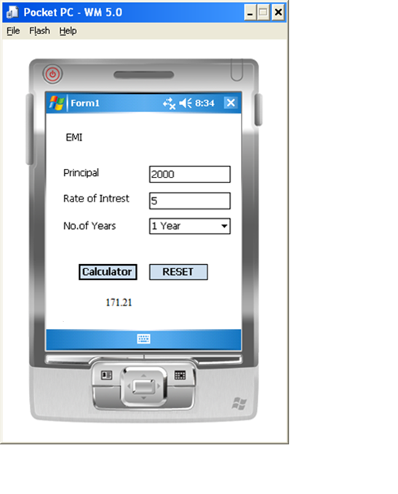

**Practical No: 10**

**Aim:** Design Image Dropdown List in Windows Mobile.

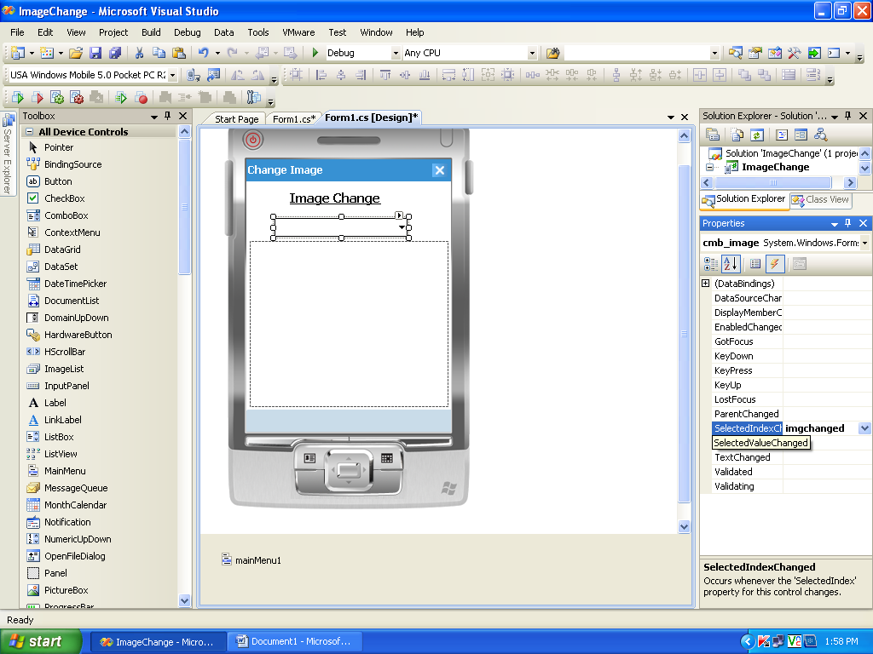

**Code:**

using System;

using System.Linq;

using System.Collections.Generic;

using System.ComponentModel;

using System.Data;

using System.Drawing;

using System.Text;

using System.Windows.Forms;

namespace ImageChange{

public partial class Form1 : Form

{

public Form1(){

InitializeComponent();

}

private void imgchanged(object sender, EventArgs e){

System.Uri imgpath = new Uri(@"file://\My Documents\My Pictures\" + cmb_image.SelectedItem.ToString() + ".jpg");

wb.Navigate(imgpath);

}

}

}

**Output:**

